**PROJECT ABSTRACT**

**TOPIC: Small Scale Enterprise.**

**Submitted by;**

Bhagyasree Raj

S5 MCA Regular

Roll No: 17

**Small Scale Enterprise (SSE)**

SSE is to provide customers with products at lowest price. If a customer needs a product, he can search for that particular item in this website. Based on his search, the website will list out sellers around him. The customer can compare same product of different shops at the same time. Based on that comparison they can buy the product with lowest price. In the case of the seller he can sell the product at lowest cost.

**Main Features:**

* Booking Facility.
* Purchasing Facility.
* Searching Facility.
* Customizing According to location.
* View Purchase History.

**MODULES**

1. Admin

* Manage Products.
* Approve and Block Seller.
* Add Category.

1. Seller

* Registration.
* Login.
* Upload product details.
* Manage Profile (View, Edit, Delete).0

1. Customer

* Registration.
* Login.
* Manage Profile.
* Search Products.
* Give feedback.

**USE CASE DIADRAM**

**Usecase Diagram for admin**

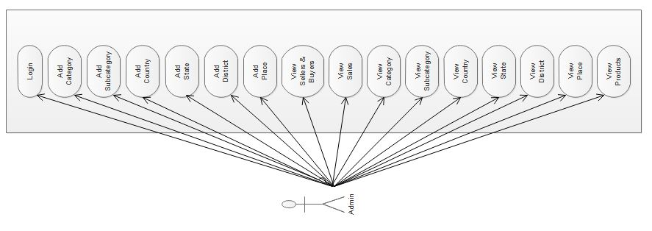

**Usecase Diagram for buyer**

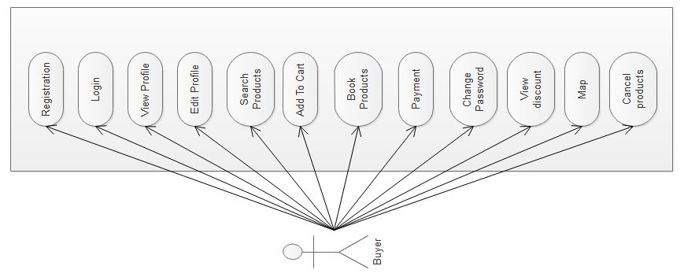

**Usecase Diagram for seller**

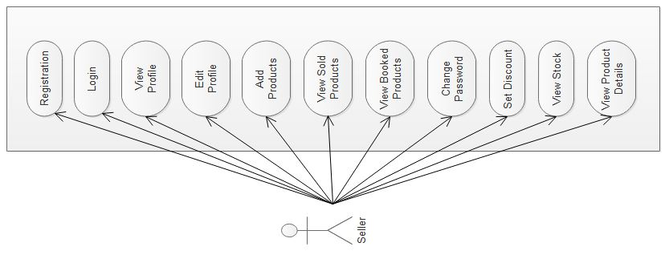

**TABLES**

***Table No 1: login***

Primary key: userid

|  |  |  |  |
| --- | --- | --- | --- |
| **Field** | **Data type** | **Size** | **Description** |
| Userid | Int | 11 | User login id primary key |
| Username | Varchar | 65 | username |
| Password | Varchar | 65 | password |
| Role_id | Int | 11 | login role (admin, buyer, seller) |
| Status | Int | 11 | Valid/invalid |

***Table No 2: role***

Primary key: role_id

|  |  |  |  |
| --- | --- | --- | --- |
| **Field** | **Data type** | **Size** | **Description** |
| Role_id | Int | 11 | role id primary key |
| Role_name | Varchar | 65 | Role name |
| Status | int | 11 | Valid/invalid |

***Table No 3: customer***

Primary key: customer_id

Foreign key: userid

Foreign key: place_id

|  |  |  |  |
| --- | --- | --- | --- |
| **Field** | **Data type** | **Size** | **Description** |
| Customer_id | Int | 11 | customer id primary key |
| userid | Int | 11 | User id primary key of table login |
| First_name | Varchar | 65 | First name |
| Last_name | Varchar | 11 | Last name |
| Mobile_number | Number | 65 | Mobile number |
| Email | Varchar | 65 | Email id |
| Place_id | Int | 11 | Place id primary key of table place |
| username | Varchar | 65 | Username |
| password | Varchar | 65 | Password |

***Table No 4: seller***

Primarykey:seller_id

Foreign key:userid

Foreign key: place_id

|  |  |  |  |
| --- | --- | --- | --- |
| **Field** | **Data type** | **Size** | **Description** |
| Seller_id | Int | 11 | Seller id primary key |
| userid | Int | 11 | User id primary key of table login |
| First_name | Varchar | 65 | First name |
| Last_name | Varchar | 65 | Last name |
| Store_name | Varchar | 65 | Store name |
| Mobile_number | Number | 65 | Mobile number |
| Email | Varchar | 65 | Email id |
| Place_id | Int | 11 | Place id primary key of table place |
| Gst_no | Int | 11 | Gst number |
| username | varchar | 65 | Username |
| password | varchar | 65 | password |

***Table No 5: category***

Primarykey:category_id

|  |  |  |  |
| --- | --- | --- | --- |
| **Field** | **Data type** | **Size** | **Description** |
| Category_id | Int | 11 | Primary key |
| Category_name | Varchar | 65 | Category name |
| Category_des | Varchar | 100 | Category Description |

***Table No 6: subcategory***

Primarykey:subcategory_id

Foreign key: category_id

|  |  |  |  |
| --- | --- | --- | --- |
| **Field** | **Data type** | **Size** | **Description** |
| Subcategory_id | Int | 11 | Primary key |
| Category_id | Int | 11 | Primary key of table category |
| Subcategory_name | Varchar | 65 | Subcategory name |

***Table No 7: product***

Primarykey:product_id

Foreignkey:userid

Foreign key: subcategory_id

|  |  |  |  |
| --- | --- | --- | --- |
| **Field** | **Data type** | **Size** | **Description** |
| Product_id | Int | 11 | Primary key |
| userid | Int | 11 | Foreign key of table login |
| Subcategory_id | Int | 11 | Primary key of table subcategory |
| Product_name | Varchar | 65 | Product name |
| Description | Varchar | 65 | Description |
| quantity | Int | 11 | quantity |
| Cost_price | Varchar | 65 | Cost price |
| Selling_price | Varchar | 65 | Selling price |
| Image | Varchar | 65 | Image |

***Table No 8: booking***

Primarykey : bookid

Foreign key : product_id

Foreign key : userid

|  |  |  |  |
| --- | --- | --- | --- |
| **Field** | **Data type** | **Size** | **Description** |
| Bookid | Int | 11 | primary key |
| Product_id | Int | 11 | foreign key –product |
| Userid | Int | 11 | foreign key – login |
| Quantity | Int | 11 | quantity |
| amount | Varchar | 65 | amount |

***Table No 9: country***

Primarykey:country_id

|  |  |  |  |
| --- | --- | --- | --- |
| **Field** | **Data type** | **Size** | **Description** |
| Country_id | Int | 11 | primary key |
| Country_name | Varchar | 65 | country name |

***Table No 10: state***

Primarykey: state_id

Foreign key: country_id

|  |  |  |  |
| --- | --- | --- | --- |
| **Field** | **Data type** | **Size** | **Description** |
| State_id | Int | 11 | primary key state |
| Country_id | Int | 11 | Foreign key-country |
| State_name | Varchar | 65 | State name |

***Table No 11: district***

Primarykey:district_id

foreign key : state_id

|  |  |  |  |
| --- | --- | --- | --- |
| **Field** | **Data type** | **Size** | **Description** |
| District_id | Int | 11 | primary key district id |
| State_id | Int | 11 | Foreign key state |
| District_name | Varchar | 65 | District name |

***Table No 12: place***

Primary key: place_id

Foreign key : district_id

|  |  |  |  |
| --- | --- | --- | --- |
| **Field** | **Data type** | **Size** | **Description** |
| Place_id | Int | 11 | primary key - place id |
| District_id | Int | 11 | Foreign key-district |
| Place_name | Varchar | 65 | Place name |

***Table No 13: bill***

Primary key : bill_id

Foreign key : district_id

|  |  |  |  |
| --- | --- | --- | --- |
| **Field** | **Data type** | **Size** | **Description** |
| bill_id | Int | 11 | primary key - bill id |
| userid | Int | 11 | Foreign key-login |
| product_id | int | 11 | Product id |
| Payment_type | int | 11 | COD or cash |
| date | datetime | 11 | date |

***Table No 14: discount***

Primary key: discid

Foreign key : product_id

|  |  |  |  |
| --- | --- | --- | --- |
| **Field** | **Data type** | **Size** | **Description** |
| discid | Int | 11 | primary key - discount id |
| product_id | Int | 11 | Foreign key-product |
| percentage | int | 11 | percentage |

***Table No 15: feedback***

Primary key: feedback_id Foreign key : username

Foreign key : product_id

|  |  |  |  |
| --- | --- | --- | --- |
| **Field** | **Data type** | **Size** | **Description** |
| feedback_id | Int | 11 | primary key - feedback id |
| username | Varchar | 65 | Foreign key-login |
| score | int | 11 | rating |
| feedback | Varchar | 65 | feedback |
| product_id | int | 11 | Foreign key-product |
| date | datetime | 11 | date |

***Table No 16: wishlist***

Primary key: wid Foreign key : userid

Foreign key : product_id

|  |  |  |  |
| --- | --- | --- | --- |
| **Field** | **Data type** | **Size** | **Description** |
| wid | Int | 11 | primary key - wishlist id |
| userid | Int | 11 | Foreign key-login |
| product_id | int | 11 | Foreign key-products |
| count | int | 11 | count |

**FORM DESIGN**

